SHA: the GNSS Analysis Center at SHAO
Junping Chen*, Bin Wu, Xiaogong Hu, Haojun Li
Shanghai Astronomical Observatory (SHAO), Chinese Academy of Sciences (CAS)
Telephone: 0086-21-64386191 Ext. 637
Fax: 0086-21-64386191 Ext. 637
e-mail: junping.chen@shao.ac.cn

Abstract: Today, most precise GNSS products, including orbits and clocks, are provided by the IGS (International GNSS Service) and its Analysis Centers (ACs). Each AC provides its products to the AC Coordinator (ACC) for combination. ACs develop their own software packages by implementing different strategies, which as a result improving the robustness of the combined products. Following the IGS AC strategy and to fulfill the requests of satellite missions in China, we set up the GNSS Analysis Center at Shanghai Astronomical Observatory (SHAO). Currently our GNSS routine analysis includes: Global GPS+GLONASS data processing, GLOBAL+CMONOC GPS data processing. In the first routine, we use ~110 global stations, of which ~50 have GLONASS observations, to derive the integrated and consistent GNSS products. In the second routine. We combine the IGS network used the first routine and the CMONOC (Crustal Movement Observation Network of China) network, GPS only solution is performed using ~300 stations. This paper introduces the details of the Analysis Center and presents the latest results.
Keywords: GNSS, SHA, GGDAA, CMONOC, GNSS Analysis Center
1 Introduction
With the improvement of accuracy and precision, GNSS has contributed to the mm-level applications as: earth dynamics monitoring, global reference frame definition, natural disaster monitoring, weather forecasting etc. In all these applications, precise GNSS (Global Navigation Satellite System) products including orbits and clocks play a fundamental role. Today, most precise GNSS products are provided by the IGS (Dow et al. 2009) and its Analysis Centers. Each AC provides its products to the AC Coordinator for combination. ACs develop their own software packages by implementing different strategies, which as a result improving the robustness of the combined products.
IGS products and its associating service becomes ever important in GNSS research. However, IGS does not guarantee such service. Since November 2011, the web page and FTP of the IGS are not open to Chinese IPs. GNSS community in China is thus facing a situation that other IGS services may be interrupted due to policy change of the NASA. To improve the availability of precise GNSS products and to shorten the time of products releasing, we set up the GNSS Analysis Center at Shanghai Astronomical Observatory (SHAO). The analysis center (abbreviated as SHA) follows the IGS AC strategies and aims to fulfill the requests of satellite missions in China. Currently, our GNSS routine analysis includes: Global GPS+GLONASS data processing, GLOBAL+CMONOC GPS data processing. In the first routine, we use ~110 global stations, of which ~50 have GLONASS observations, to derive the integrated and consistent GNSS products. In the second routine. We combine the IGS network used the first routine and the CMONOC network, GPS only solution is performed using ~300 stations. We presents the latest results of SHA and presents its applications.
2 Status of IGS
The applications of GNSS explores from the original navigation to other areas like meteorology, precise positioning etc. It has been applied to the ITRF definition(Zuheir et al. 2011), Earth Geo-dynamics monitoring (Moreno et al. 2011), natural disaster monitoring (Chen et al. 2010), precise orbiting for LEOs (Bock, 2003), Earth rotation parameter estimation(Mireault et al. 1999) and atmosphere monitoring (Gendt et al. 2001) etc.
Providing the most precise GNSS products, IGS and its participating agencies operates more than 400 GNSS sites. Data centers are responsible for the disseminating of observations and products. The precise IGS products includes: precise GNSS orbits and clocks, station coordinates and velocities, earth rotation parameters, atmosphere products (ZTD and TEC maps) etc. The IGS AC distributes in Europe (5), Canada (1) and USA(5). Each AC differs in data sets, software packages, and data analysis strategies, of which the results are compared and combined.
Current precision of IGS core products are listed in table 1 (IGS, 2011).
Table 1. Precision of IGS core products(IGS stands for Final products；IGR is Rapid products；IGUA is the estimating part of Ultra rapid products；IGUB is the predicting part of Ultra rapid products, i.e. real-time products)
 | GPS Orbits  (cm) | GPS clocks  (ns) | Pole  (mas) | Lod  (µs) | Coordinates(mm)/  velocities(mm/year)
IGS | 2.5 | 0.02 | 0.03 | 10 | Horizontal:  3.0/2.0  Height:  6.0/3.0
IGR | 2.5 | 0.03 | 0.04 | 10 | Horizontal:  3.0/2.0  Height:  6.0/3.0
IGUA | 3.0 | 0.05 | 0.05 | 10 | Horizontal:  3.0/2.0  Height:  6.0/3.0
IGUB | 5.0 | 1.5 | 0.20 | 50 | Horizontal:  3.0/2.0  Height:  6.0/3.0
3 Challenges of GNSS data analysis
With the development of the GNSS technology, especially with the coming new signals and new constellations, GNSS data analysis is facing new challenges:
(1)Multi-system data analysis and handling of new frequencies/data types
Most of IGS products are generated based on GPS ionosphere-free combination observations. Recently, 5 ACs start to provide GLONASS products with final orbits precision of 5cm and real-time orbits of 10cm. The inclusion of more satellite systems like GLONASS and Compass/Beidou improves the coverage of satellite constellations and can improve the precision of the common parameters(e.g. coordinates) at the stations. The general strategy for integrated GPS+GLONASS data processing follows the convention that GPS system is selected as the reference system and system biases are estimated for GLONASS satellites. With the coming Galileo system, more bias parameters have to be defined and the data processing will become ever complicated.
At the time of this writing, GPS constellation contains 7 satellites of Block IIR-M type and 2 Block IIF satellites, where Block IIR-M satellites have new L2C observations and Block IIF satellites provide observations at L5 frequency. Galileo system has even more frequencies and observation types. New types of observation may lead to a revolution of the current IGS AC strategies, which are always based on ionosphere-free L3 observations.
(2)Data analysis of huge networks
IGS provides data of more than 400 sites, each AC processes only sub-network (<250) of these stations due to limitation of computation capability. However, many regions operate much denser networks: e.g., the Southern California Integrated GPS Network (SCIGN) with ~250 stations, the European EUREF network with ~250 stations, the GEONET network in Japan with more than 1200 stations and the CMONOC network in China with ~260 stations. The integrated data processing of these huge networks requires new strategies.
(3)Real-time GNSS
Since 2007, the IGS operates the IGS-RTPP. IGS-RTPP aims to gather and distribute real-time data and products associated with GNSS satellite constellations. The primary products envisioned for the project are multi-frequency observation data and precise satellite clocks made available in real-time.
Under IGS-RTPP collaborations, there are currently more than 100 stations providing real-time streams. The RTPP AC retrieves real-time streams through the open internet protocol and estimates real-time satellite orbits and clocks. The IGS-RTPP is still at piloting stage with satellite clock sampling of 5s and a latency of 10-15s(including latency of stream, time of data analysis and internet communication). Due to the limitation of computation capabilities, most ACs use ~50 stations, the availability and robustness of their products are major problems.
4 GNSS data analysis center at SHAO (SHA)
SHAO supports the Group of GNSS Data Analysis and Applications (GGDAA) in recent years. The GGDAA works with the above-mentioned challenges and starts routine GNSS data analysis since June 2011. Following figure shows the flowchart of the data analysis system.
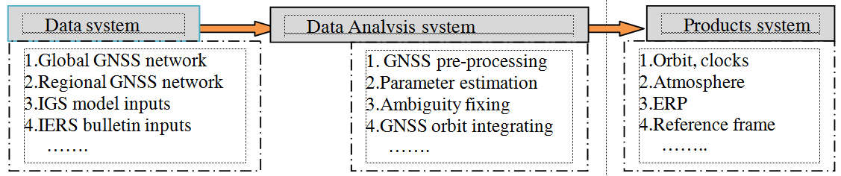
Fig. 1. Flowchart of the routine GNSS data analysis at SHAO
In Fig. 1, Data system automatically downloads GNSS observations and input tables for data analysis; the analysis system performs routine data analysis and provides parameter estimations; the products system generate all GNSS products in given internal and external formats.
Using the above platform, routine data analysis is performed using the IGS network with ~110 stations and CMONOC network with ~260 stations. The following figures illustrate the two networks.
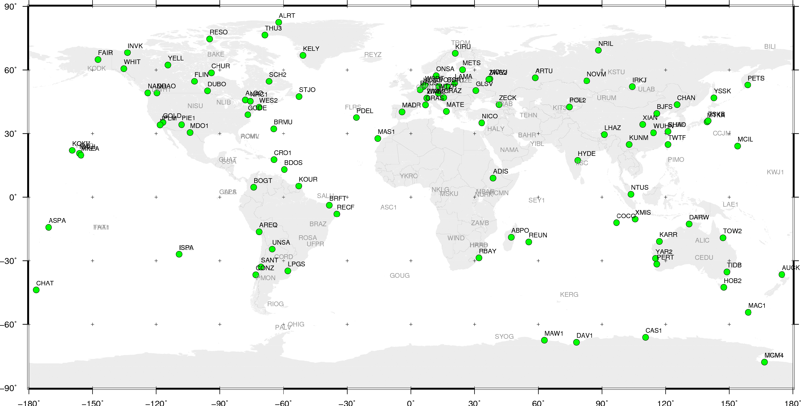
Fig. 2. IGS network processed in the GNSS routine of SHA

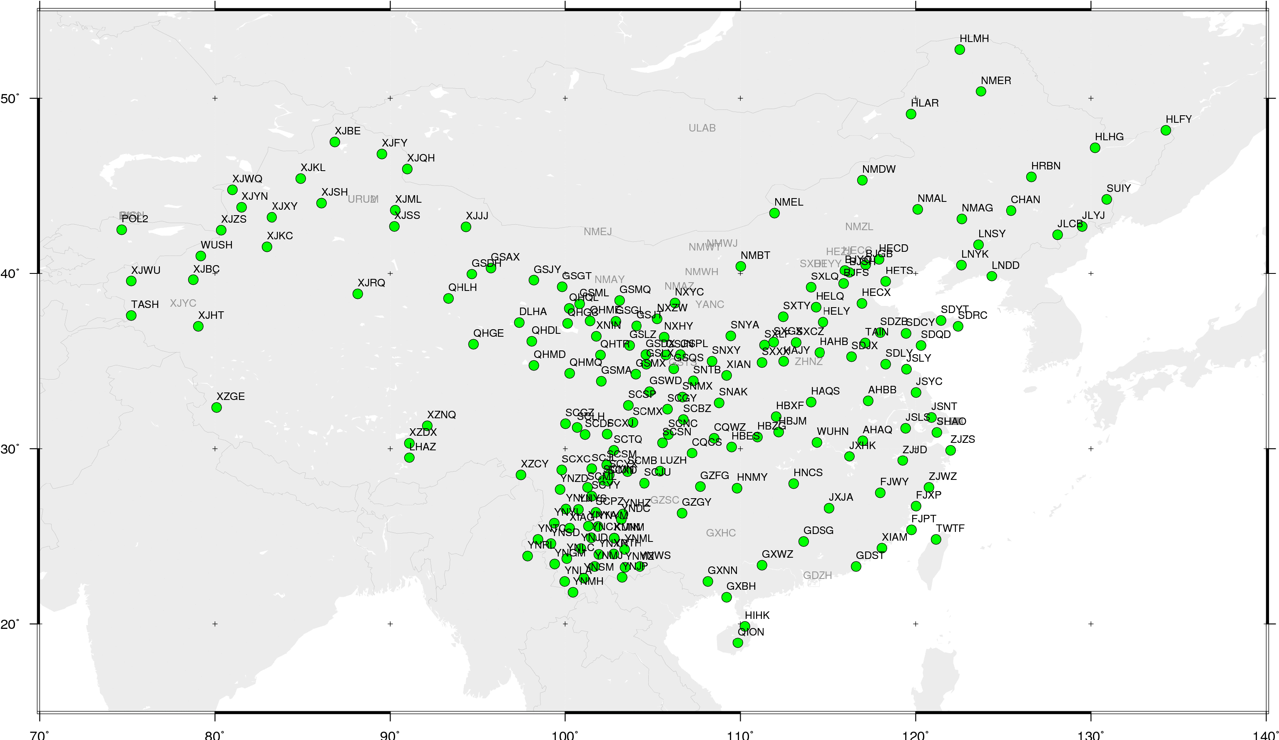
Fig. 3. CMONOC network processed in the GNSS routine of SHA
5 Products of SHA
5.1 GNSS clocks
SHA starts to provide precise GNSS products since Doy 165,2011. To validate the clock precision, we compare our GPS clocks to the IGS final clocks, our GLONASS clocks are compared to the GFZ final clocks as there are no combined IGS GLONASS clocks. The following figures show the RMS of the comparisons, where we see the precision of GPS clocks of SHA is at about 0.05ns and the precision of GLONASS clocks at about 0.15 ns.
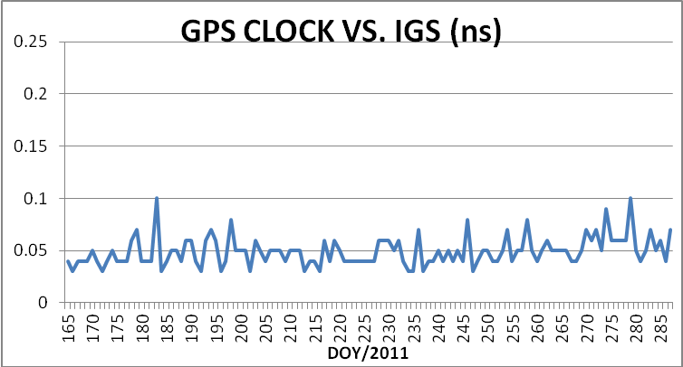
Fig. 4. Comparison of GPS clocks between SHA and IGS. Results show the RMS in mm.
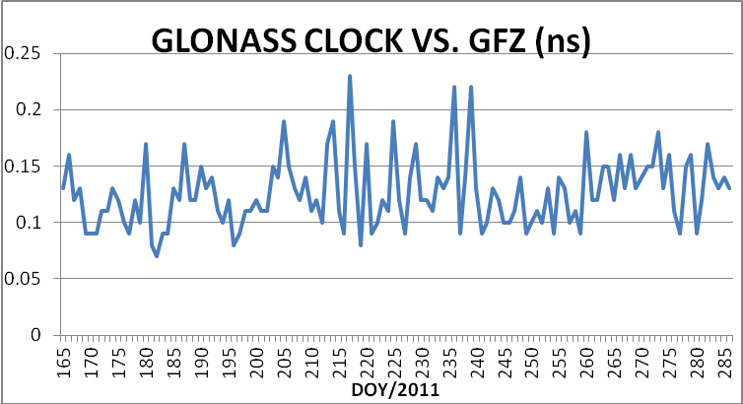
Fig. 5. Comparison of GLONASS clocks between SHA and GFZ. Results show the RMS in mm.
5.2 GNSS Orbits
To validate the GNSS orbits precision, we compare our GPS orbits to the IGS final orbits, our GLONASS orbits are compared to the GFZ final orbits. The following figures show the RMS of the comparisons, where we notice that GNSS orbits of SHA are better than some of IGS ACs with precision of GPS orbits is at 2cm and GLONASS orbits at 4cm.
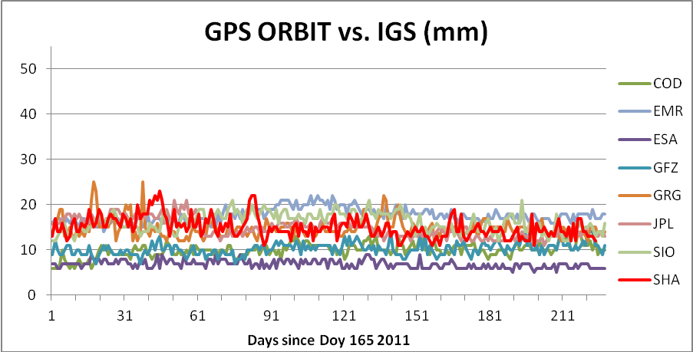
Fig. 6. Comparison of GPS orbits between SHA and IGS. Results show the RMS in mm.
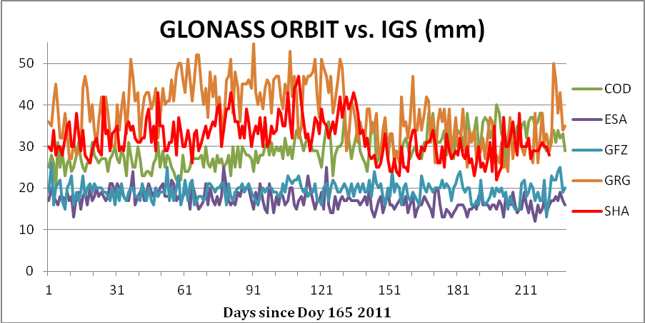
Fig. 7. Comparison of GLONASS orbits between SHA and GFZ. Results show the RMS in mm.
5.3 GPS/GLONASS time offset
The Time Offset(TO) between GPSt and GLONASST can be derived from the following equations:
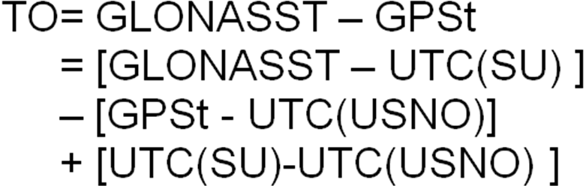 (1)
In (1), the first two terms GLONASST – UTC(SU) and GPSt - UTC(USNO) are monitored at monitoring stations of each satellite system and they are encoded in the navigation files using predicted values. The latter part UTC(SU)-UTC(USNO) is in the order of few ns and can be retrieved in the BIPM bulletin with a latency of ~1 month.
SHA performs the integrated processing of GPS and GLONASS observations, through which the TO between GPSt and GLONASST could be monitored using the following equations:
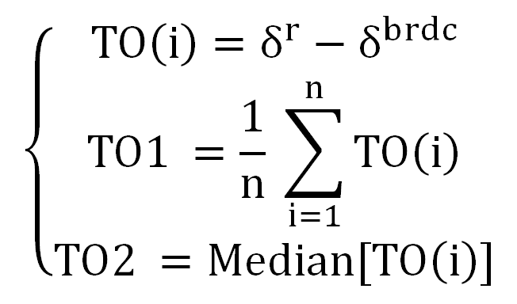 (2)
In (2), the term $δ^{r}$is the GLONASS clock from SHA estimation, which is under the time frame of GPSt; $δ^{\text{brdc}}$is the GLONASS clock from the broadcast, which is under the time frame of GLONASST. The following figure shows the TO between GPSt and GLONASST using (1) and (2). In Fig.8, the term UTC(SU)-UTC(USNO) is ignored due to its long latency, which accounts for additional few ns errors. The agreement between the two approaches is better than 10ns.

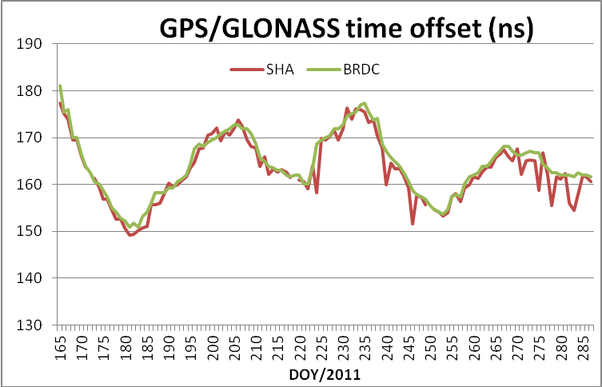
Fig. 8. GPS/GLONASS time offset in ns, where SHA illustrates TO derived from Eq.(2) using the SHA integrated GNSS solutions; BRDC presents TO calculated from Eq.(1) with the first two terms from daily navigation files and the term UTC(SU)-UTC(USNO) is being ignored.
5.4 Station coordinates
Selecting 18 stations from the CMONOC network, figure below shows the PPP coordinates repeatability from DOY165 to 167, 2011.
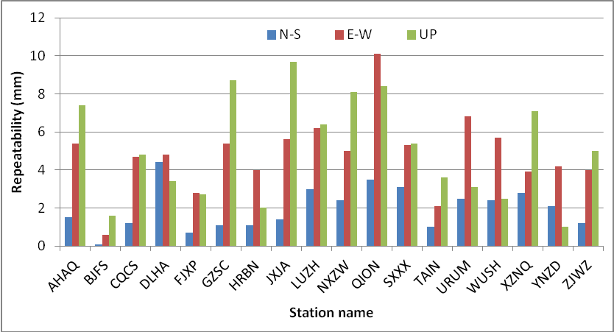
Fig. 9. PPP coordinates repeatability using precise orbits and clocks of SHA
6 Conclusion
We present the current challenges of GNSS data analysis. The GNSS data analysis center at SHAO is introduced and the routine results of SHA are presented. The GNSS routine processing of SHA provides integrated solutions, where all products are based on common references. The products of SHA are at the same precision level of IGS products and have been applied to satellite missions of China. Related researches are being carried out within the GGDAA group based on the routine results.
Acknowledgments: This research is supported by 100 Talents Programme of the Chinese Academy of Sciences. IGS community is acknowledged for providing Rinex data.
References
[1] Bock H.(2003) Efficient Methods for Determining Precise Orbits of Low Earth Orbiters Using the Global Positioning System. Phd thesis, Astronomical Institute University of Berne, Switzerland, 2003
[2]Caissy M. (2006): The IGS Real-time Pilot Project –Perspective on Data and Product Ceneration, report at Streaming GNSS Data via Internet Symposium, 6-7 Feb, 2006 Frankfurt.
[3]Chen, J.; Bender, M.; Beyerle, G.; Dick, G.; Falck, C.; Ge, M.; Gendt, G.; Heise, S.; Ramatschi, M.; Schmidt, T.; Stosius, R.; Wickert, J. (2010): GNSS Activities for Natural Disaster Monitoring and Climate Change Detection at GFZ - an Overview. - In: Chuvieco, E.; Li, J.; Yang, X. (Eds.), Advances in Earth Observation of Global Change, Springer, 159-172.
[4]Dow J.M., Neilan R. E., and Rizos C. (2009): The International GNSS Service in a changing landscape of Global Navigation Satellite Systems, Journal of Geodesy 83:191–198, DOI: 10.1007/s00190-008-0300-3
[5]EUREF :http://epncb.oma.be/
[6]Gendt G, C Reigber, G Dick (2001) Near real-time water vapor estimation in a German GPS network-first results from the ground program of the HGF GASP project.Physics and Chemistry of the Earth.Part A:Solid Earth and Geodesy 26(6-8): 413-416
[7]GEONET: https://www.geonetjapan.com/
[8]IGS (2011): http://igscb.jpl.nasa.gov/
[9]Moreno M et al.(2011) Heterogeneous plate locking in the South–Central Chile subduction zone: Building up the next great earthquake，Earth and Planetary Science Letters Volume 305, Issues 3-4, 15 May 2011, Pages 413-424
[10]Mireault Y., Kouba J. and Ray J. (1999): IGS Earth Rotation Parameters.GPS Solutions,Volume 3,Number 1, 59-72, DOI: 10.1007/PL00012781
[11]SCIGN: http://www.scign.org/
[12]Shanghai Observatory GNSS Analysis Center: www.shao.ac.cn/shao_gnss_ac.
[13]Zuheir A., Xavier C., Laurent M. (2011): ITRF2008: an improved solution of the international terrestrial reference frame, J Geod, DOI 10.1007/s00190-011-0444-4

