BDS PPP Performance
Junping Chen, Yize Zhang and GGDAA group
Following is PPP statistics for 17 BDS stations.
Data processing are performed using the LTW_BS (Wang and Chen, 2011) software developed at SHAO. Statistics show the repeatability of PPP coordinates in North, East and Upper components, respectively.
Considering different satellite phase center corrections, data processing are performed in four scenarios: OFF-C,OFF-NOC,ON-C,ON-NOC. “OFF-C” scenario are most close to the current GPS correction mode, and mean repeatability are 1.2,3.3,4.5 cm for N E U components, respectively.
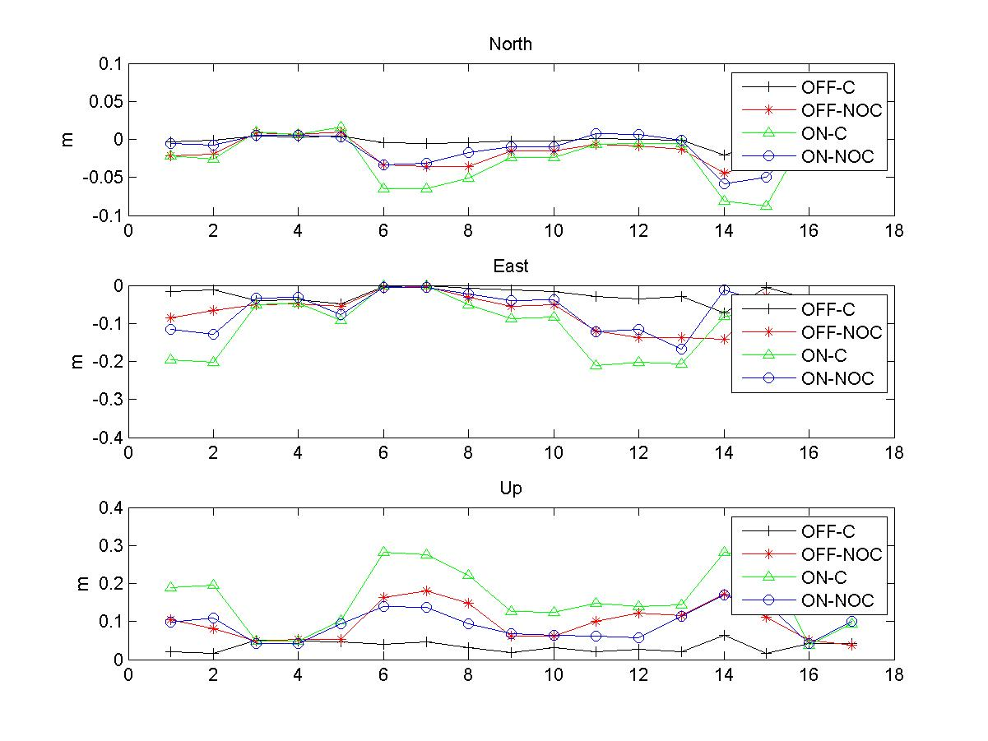
Fig. 1 PPP repeatability of COMPASS station

Wang, J., and J. Chen, 2011. Development and application of GPS precise positioning software. Journal of Tongji University (Natural Science) 39(5): 764–767. (in Chinese)
Chen, J., Wu, B., Hu, X., Li, H.(2012) SHA: The GNSS analysis center at SHAO, in: Lecture Notes in Electrical Engineering, v 160 LNEE, p 213-221

